Interactive application

Task 1 (P.1.)

When choosing a game engine it is important to see what kind of game one is trying to create

**Step 1: Understand The Genre**

Before you can do anything, you need to completely understand your game. You need to know more then just the basic storyline. Are you planning on creating a first person shooter or the next Flappy Bird? What is the mood of the game? What about user experience? You need to think through these big picture elements of your game long before you can choose the best engine for you.

**Step 2: Figure Out the Dimension**

Are you creating a 2D or a 3D game. Obviously this is a major distinction and will definitely factor into your game engine decision. Certain engines can handle both but even these tend to have a specialty in one dimension or the other.

**Step 3: Determine the Platform**

Are you creating a multi-platform game? You need to figure out if your game will be played on mobile, PC, Mac, Playstation, XBox, etc. There are many platforms out there and certain game engines won’t let you publish your game to all of them, so you need to think this through before selecting your engine.

**Step 4: Choose a Language**

What programming language are you going to use for your game? You will most likely want to pick the language that is native for your platform. While this isn’t completely necessary, it will make life easier for you down the road. Many game engines  use of a variety of languages but make sure that the one you choose is able to handle your language of choice.

**Step 5: Determine the Controls**

Once you have the platform figured out, you will most likely know if the game is going to be controlled with a keyboard or a touch screen  Do you need any special features for the game control? Are there any unique video or music inputs? These are all necessary to think through as you figure out how to build your game.

**Step 6: Think About Colors**

What are the colors that you will be utilizing for this project? What is the style of the game? Figure out if you will need any special graphical elements such as shaders or particle effects.

**Step 7: Identify Your Game Plan**

Now it is time to start thinking about the business. Are you thinking of create a free HTML5 Game? Maybe you want to sell your game to be played on any of the major gaming consoles. Regardless of what your plans are, you need to think through this. Many game engines will require royalties from your sales. This can add up quick, if you are building the next big thing so choose wisely.

**Step 8: Look at the Updates**

This is another element that isn’t always considered when people choose a game engine, but it should be. Take a look at the engines HISTORY, CHANGELOG file or if it is an open sourced engine then refer to their commit log.

If the engine you are considering to use hasn’t been updated in over a year then this should send up some major red flags. If they are not properly updating then this will impact your experience. First, you won’t be using the most up-to-date software and you will probably run into a few bugs along the way.

Task 2(p1.2)

How does unity cater for different sized screens and resolutions?

GUI units are screen pixels. If you resize your screen, the GUI objects remain anchored to their positions relative to the top left screen corner. There are two ways to reescale GUI coordinates: calculating them based on screen size in the OnGUI routine, or change the GUI matrix to keep them proportional to the screen size. Both methods have their pros and cons. Calculating the coordinates proportionally to the screen size will keep things in their relative places (itens aligned to the right side of the screen will still be right aligned, for instance) but the text itens will not be scaled - in a bigger screen they may seem too small.

Changing the GUI matrix will scale everything. It's easier, but the problem is when the screen aspect differs from the original. If you design your controls in the 4:3 format, in a wide screen they will appear stretched horizontally, and vice versa. You can set the proportion only to height or width, but the relative position of controls aligned to the right or bottom sides may be clipped or shifted to the left.

EDITED: The original width and height must be defined in the originalWidth and originalHeightvariables below. In the OnGUI function, the original GUI.matrix is saved and substituted by a new one with the scale modified to keep the original proportions. Everything in GUI will be scaled, from coordinates to text and images. If some GUI item Rect uses Screen.width or Screen.height to calculate its position (to align at the bottom or at the right, for instance), substitute by originalWidth and originalHeight.

Task 3(p2.1)

Show how sound effects are imported onto the game (show screen shots), also show a few sound editing tools used for your sound effects you used to modify your sound

How to import sound Effects

Step1: Go to the directory of the game and click on the Assets Folder

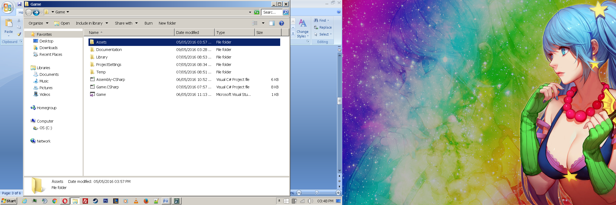

Step2: Create a folder so you can store your sound effects.

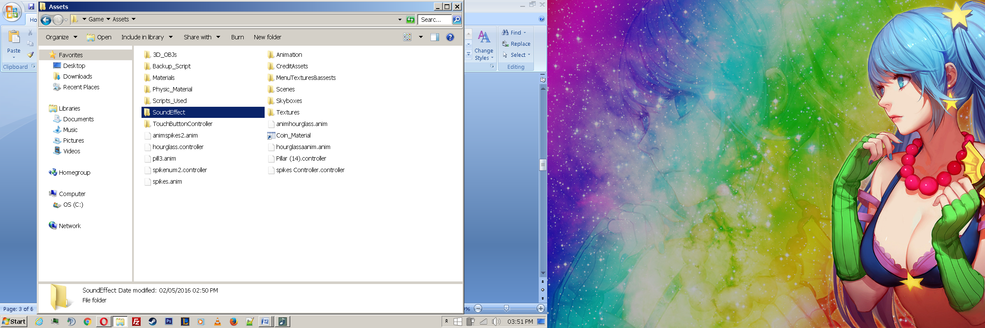

Step3: Any files in this folder will be displayed in Unity as shown below

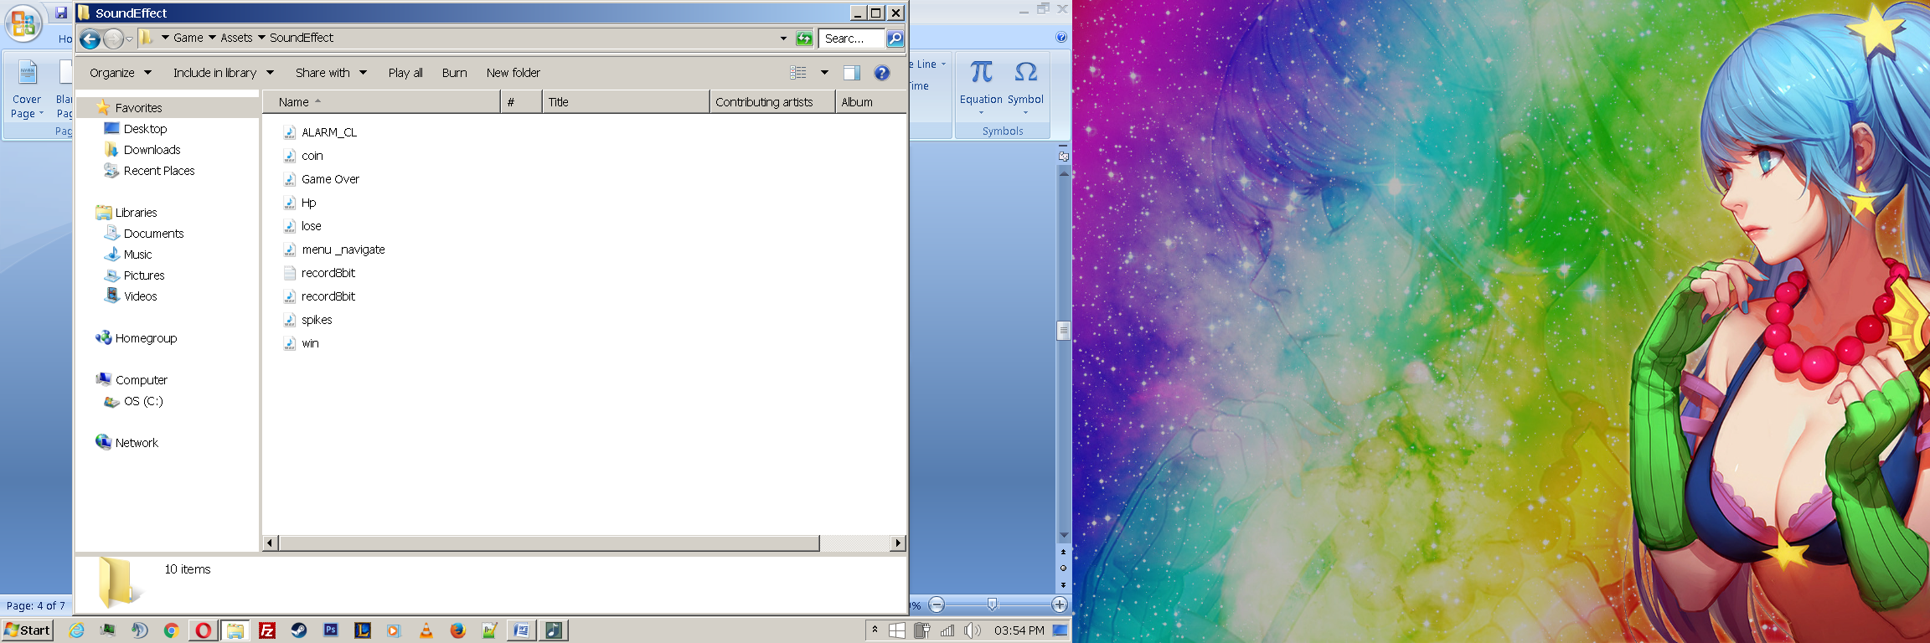 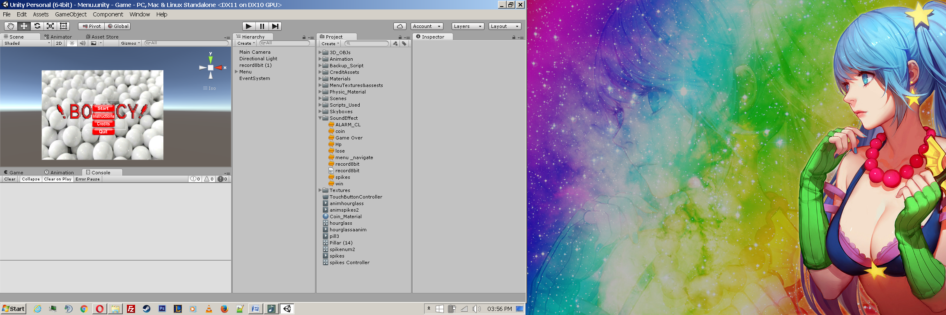

Step4;Method1: I clicked on "Add Component" , attached Audio Source and Event trigger to the start button in the Main menu so when you click / hover on the button, it will play the sound allocated to it .For example "menu_navigate" sound effect shown below:

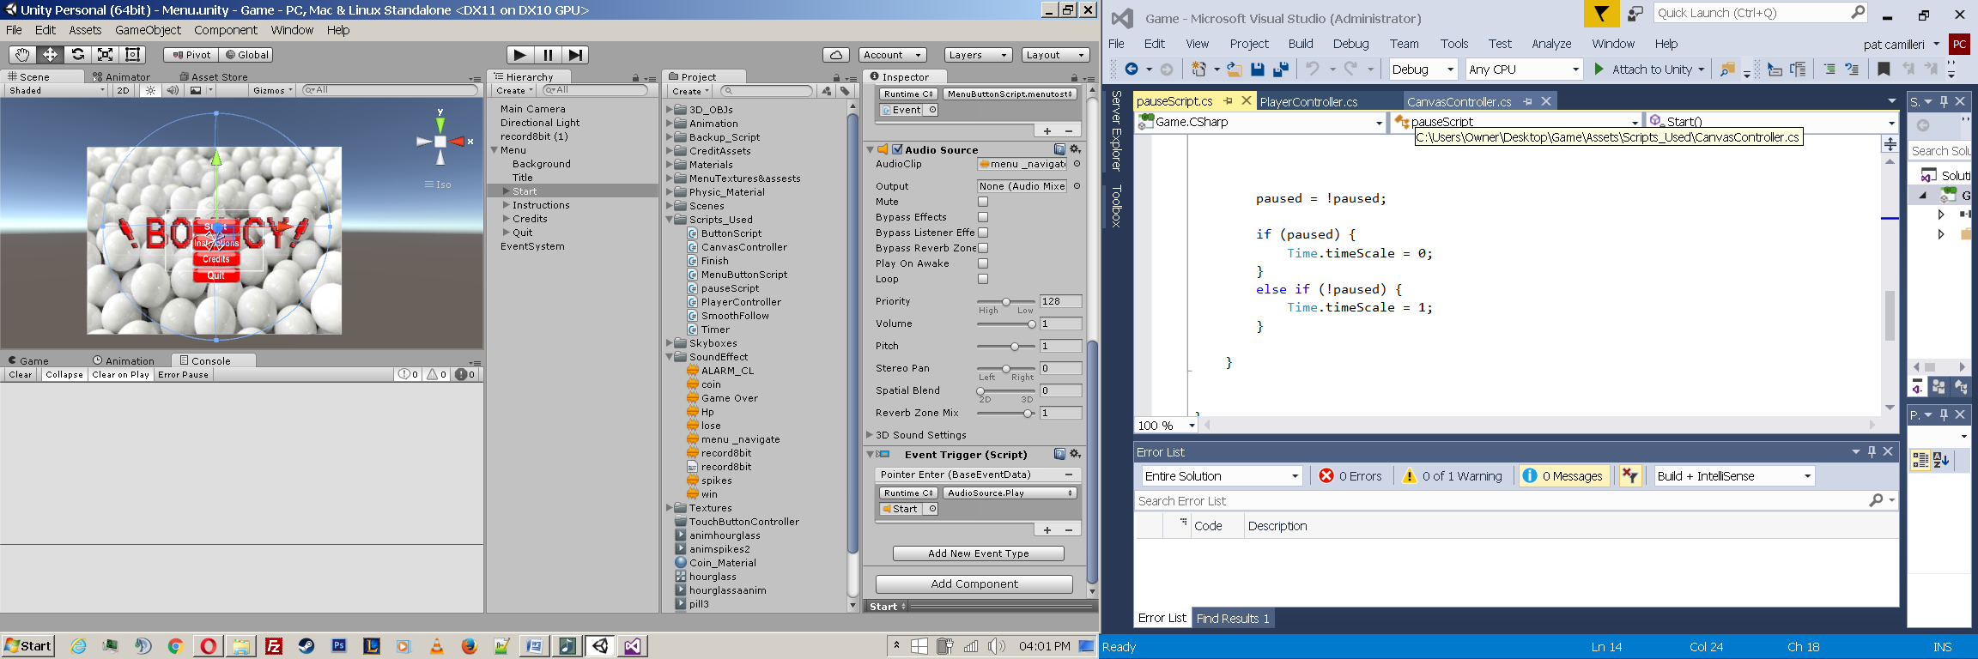

Step4;Method2;Part1: Inserted this code into the script PlayerController.cs so that when the player hits an "pick up" object for example a coin the sound effect will be triggered

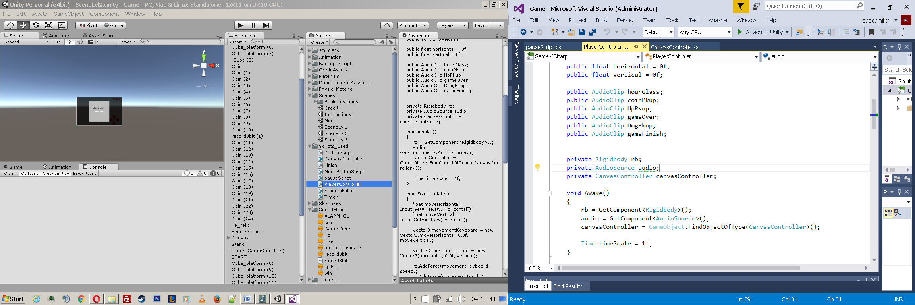 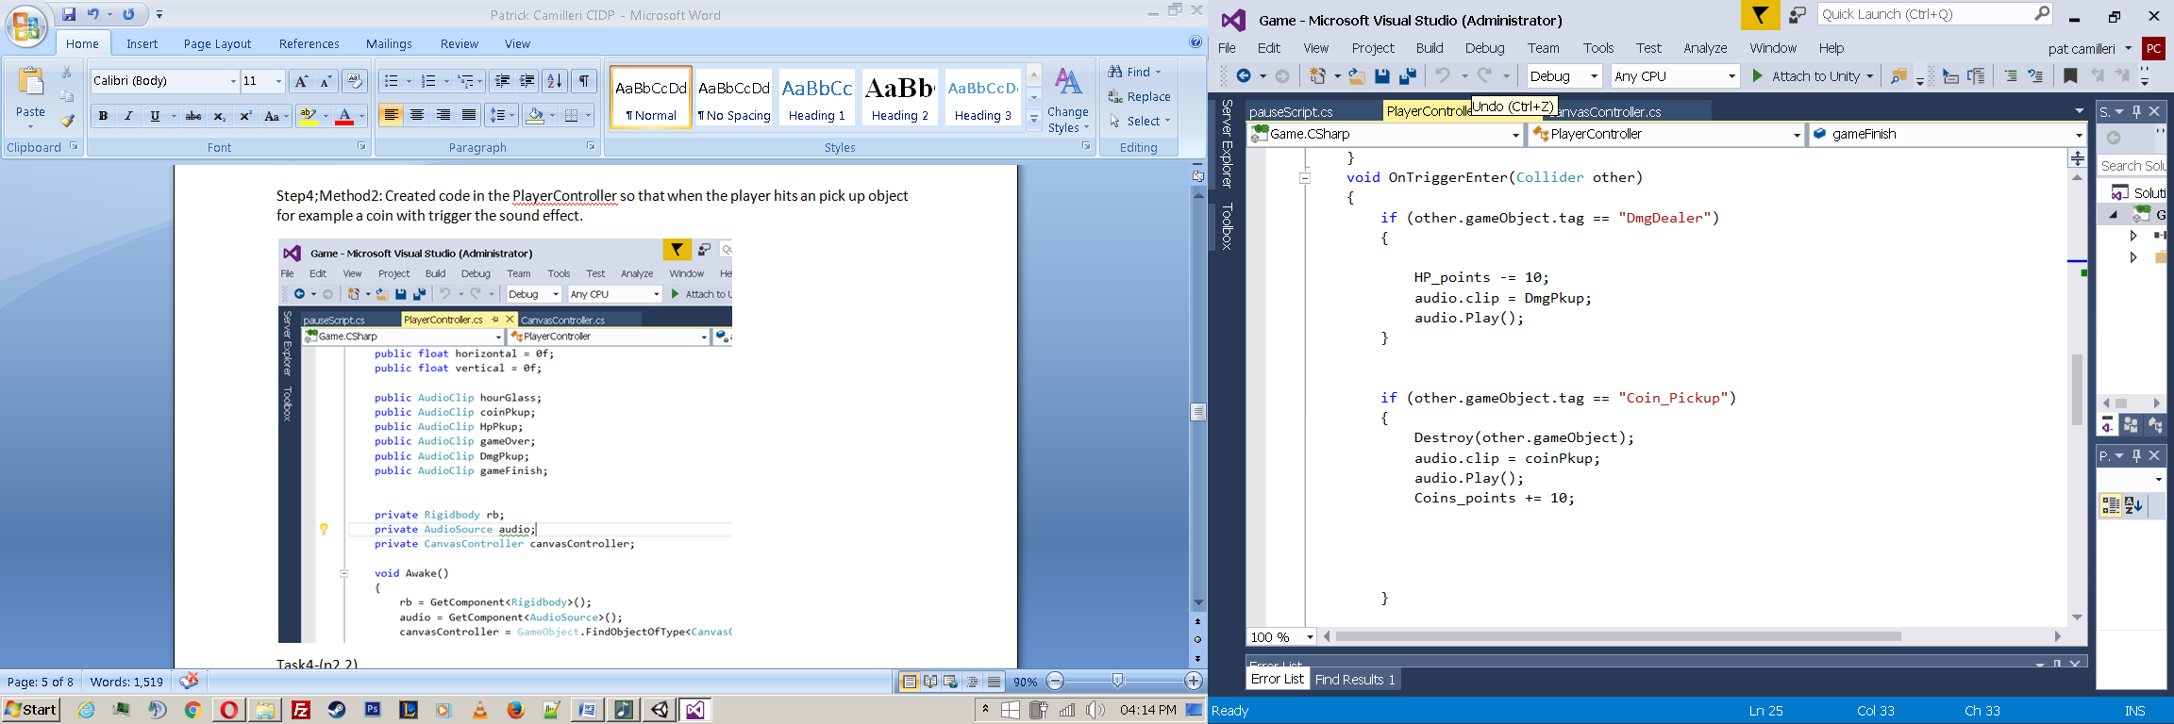

Step4;Method2;Part2: I gave the objects a tag so to link them with the code shown above.

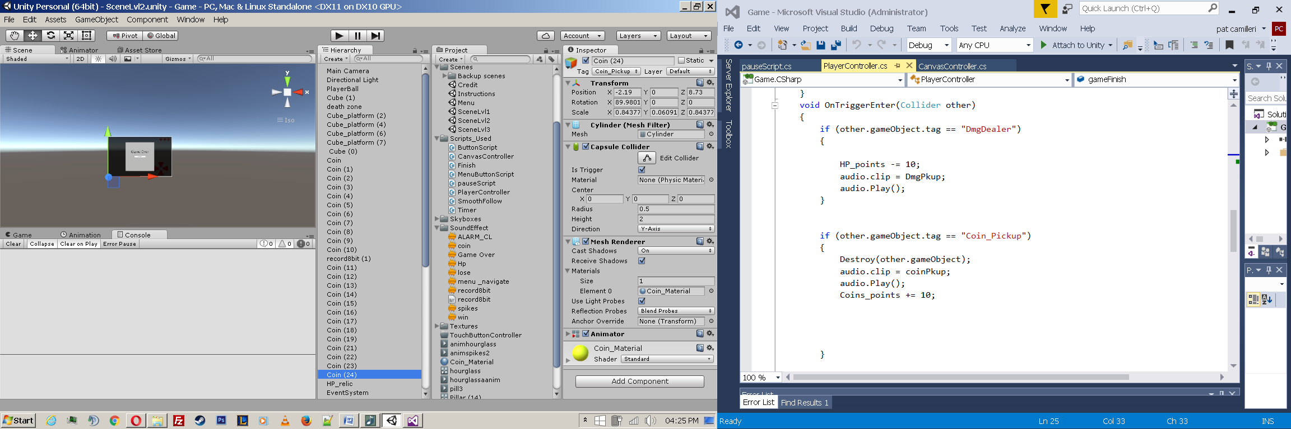

Step4;Method3: Drag and drop on to the scene.

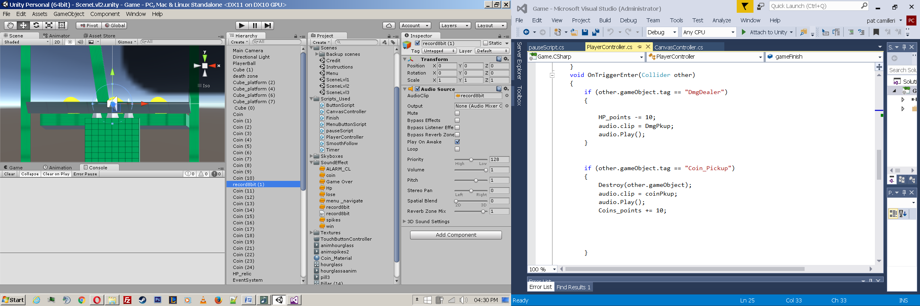

Tools use to created/modify sound / sound effects

BeepBox version 1.1.4:

Used to create 8-bit chip tune background sound and effects

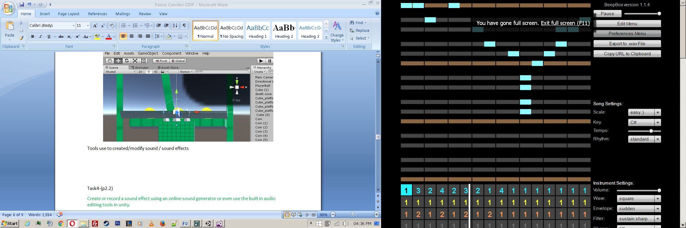

Adobe Premiere Pro



I used Adobe Premiere Pro as a recorder and to adjust the audio and modify/reduce the time of the clip using the timeline features.

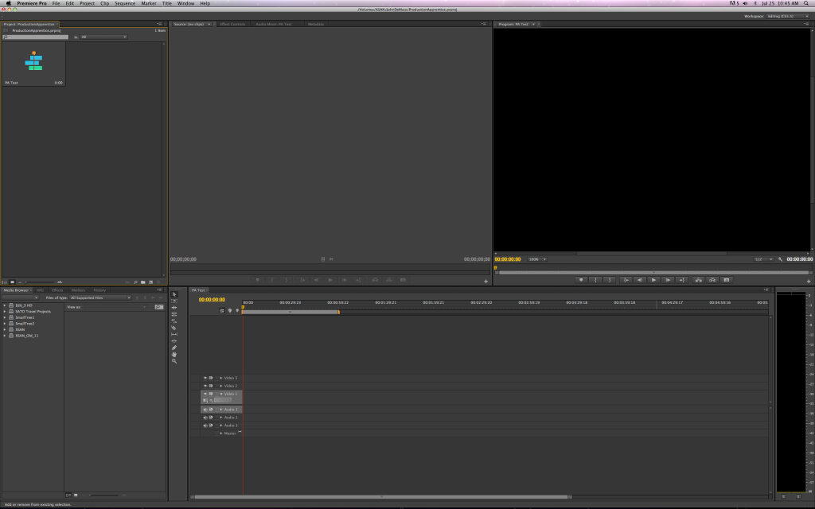

Task4-(p2.2)

BeepBox version 1.1.4:

I created this tune using this online application. I first started to create the first piece of the tune by selecting the note on the screen and adjusting the settings as shown below.

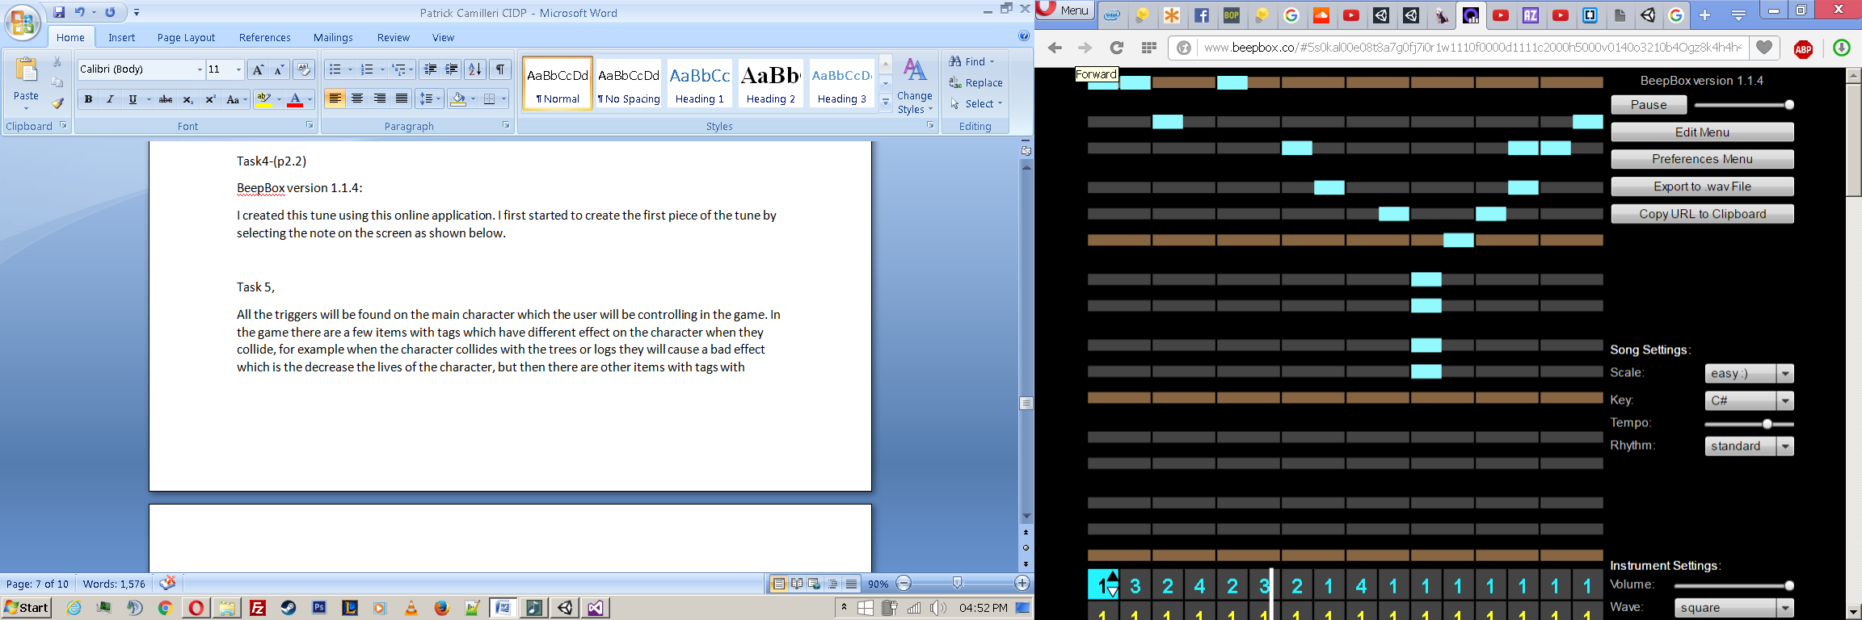

Every frame of the track is numbered so you can easily mix and adjust the tune to your liking. Each row has a different sound, varies from high to low pitch sounds. The purple scroll is there so you can shorten or lengthen the track as you please. For example:

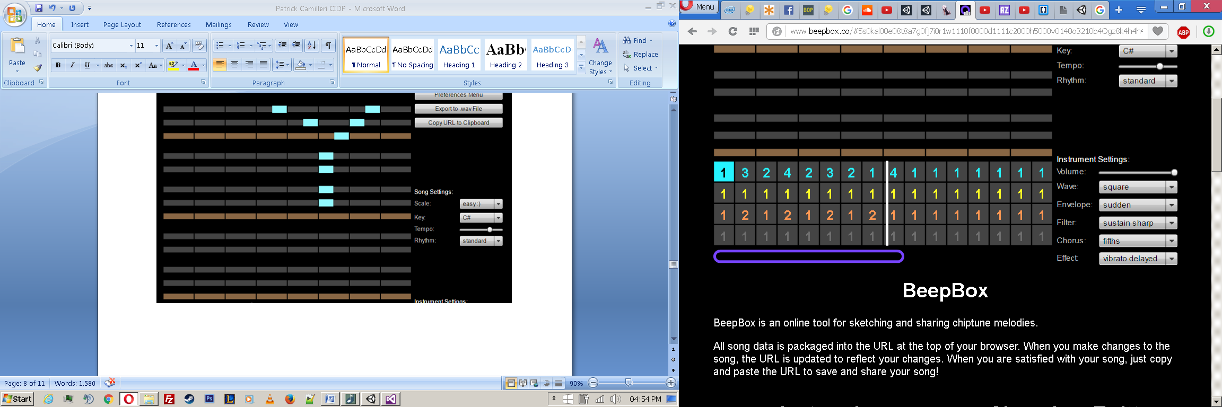

Task 5,

All the triggers will be found on the main character which the user will be controlling in the game. In the game there are a few items with tags which have different effect on the character when they collide, for example when the character collides with the trees or logs they will cause a bad effect which is the decrease the lives of the character, but then there are other items with tags with different effects which in not effect just the lives (increases the lives) but will either increase the players score or add time to the time in the game.

Difference between a collision and trigger ???

A trigger is just a way of using the basic collider mechanics for a different purpose. Normally, a collider. *collides* into something, which means the objects apply a force to each other. This implies that the engine, internally, has to be able to detect when one collider overlaps another. The same overlap detection can also report when an object has entered a particular area, but without activating the collision force. A trigger is just a collider set only to report overlaps rather than apply a force.  
  
Most solid objects in a game are just ordinary colliders. Use a trigger when you want something reminiscent of the sensor of an automatic door or hand-dryer.

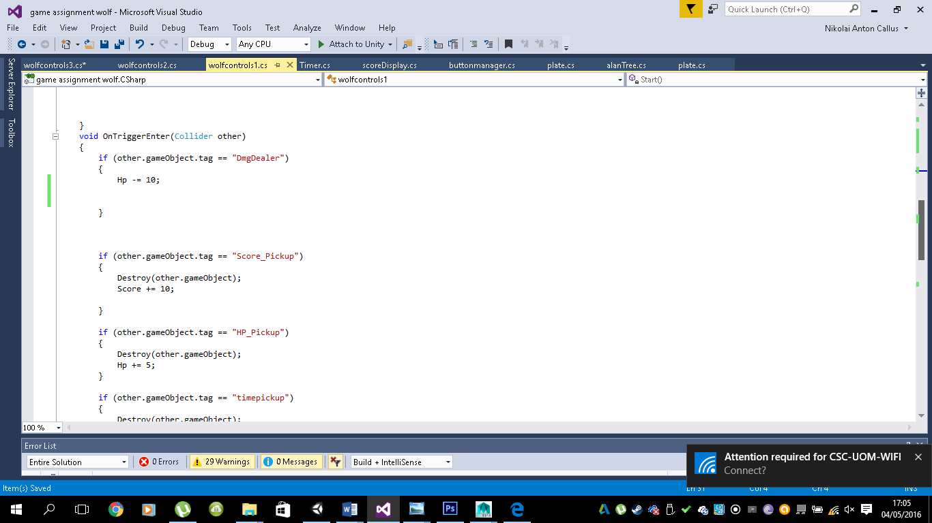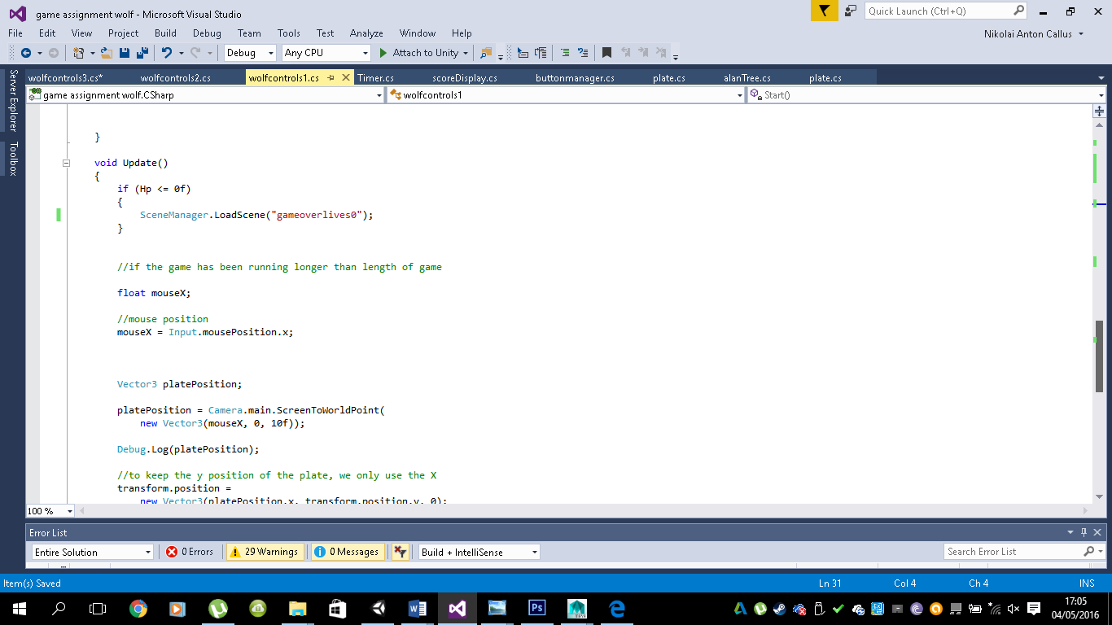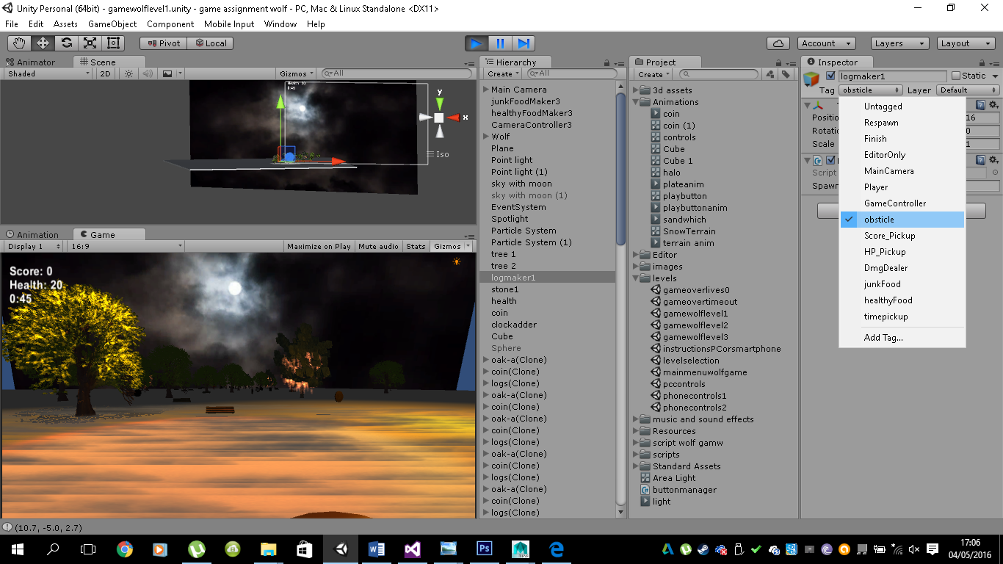

Task 6

-🡪 include sketch of the main menu and of the game screen

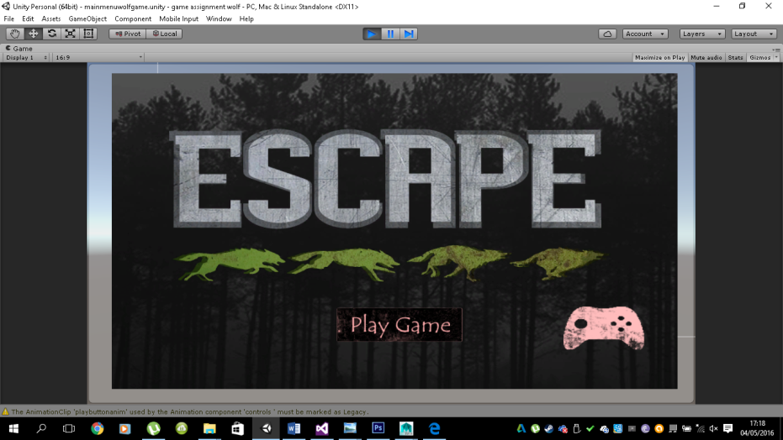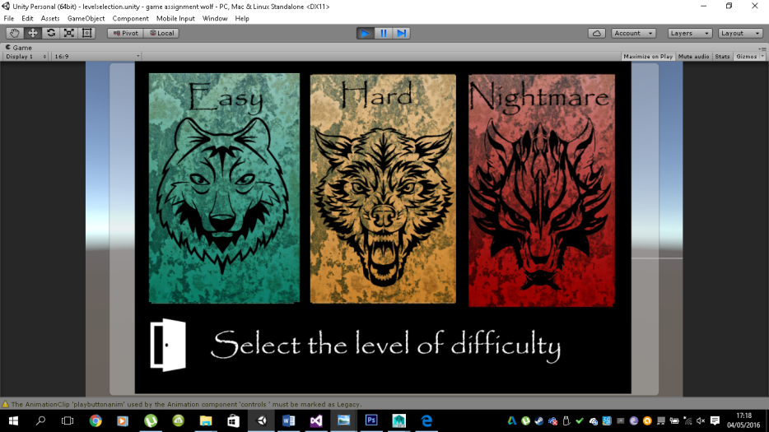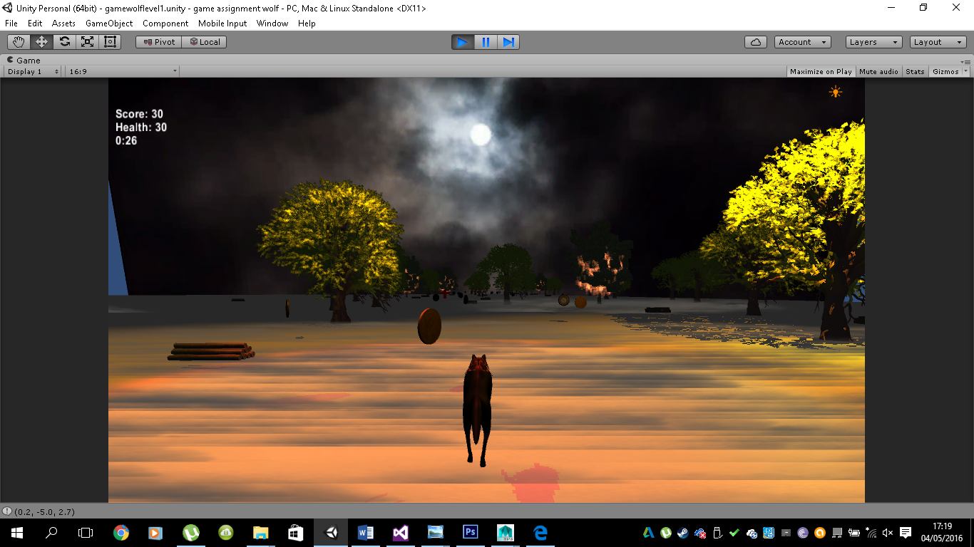

Task 7 (p4.1)

* Start(),

Description

Start is called on the frame when a script is enabled just before any of the Update methods is called the first time.

Like the Awake function, Start is called exactly once in the lifetime of the script. However, Awake is called when the script object is initialised, regardless of whether or not the script is enabled. Start may not be called on the same frame as Awake if the script is not enabled at initialisation time.  
  
The Awake function is called on all objects in the scene before any object's Start function is called. This fact is useful in cases where object A's initialisation code needs to rely on object B's already being initialised; B's initialisation should be done in Awake while A's should be done in Start.  
  
Where objects are instantiated during gameplay, their Awake function will naturally be called after the Start functions of scene objects have already completed.

* Update(),

Description

Update is called every frame, if the MonoBehaviour is enabled.

Update is the most commonly used function to implement any kind of game behaviour.

In order to get the elapsed time since last call to Update, use Time.deltaTime. This function is only called if the Behaviour is enabled. Override this function in order to provide your component's functionality.

* StartCoroutine(“coroutinename”)

|  |
| --- |
|  |

Description: Starts a coroutine.

The execution of a coroutine can be paused at any point using the yield statement. The yield return value specifies when the coroutine is resumed. Coroutines are excellent when modelling behaviour over several frames. Coroutines have virtually no performance overhead. StartCoroutine function always returns immediately, however you can yield the result. This will wait until the coroutine has finished execution.

http://docs.unity3d.com/ScriptReference/MonoBehaviour.StartCoroutine.html

When using JavaScript it is not necessary to use StartCoroutine, the compiler will do this for you. When writing C# code you must call StartCoroutine.

Task 8 (p4.2)

* Objectives
  + Player object with score- the user will have to collect the coins in order to increase his/her score
  + Player actions- the user will have the controls to navigate right and left and will be able to jump in order to avoid the obstacles in the game. Apart from the actions on the character the user will have two button on the top corners of the screen which are to either pause the game being played or to just exit the game which will take the user to main menu,
  + The menu will have the options to take the user so that he can choose his level of difficulty and a button that will close the game.
  + The main objective of the game is to go the specified time without losing his/her lives but the user can collect time perks so that the time can be extended in order to collect more points.
  + The educational element in this game is to make users aware of deforestation.
* Add screen shots of every scene and include instructions

The game is played with the user moving right, left and jump over objects in order to avoid the coming obstacles and survive until the timer reaches Zero. The user can also collect the time power up in order to extend his/her time so that they can collect more points in order to increase their score.

Task 9 (p4.3)

Had I had more time I would have improves the aesthetics of the game so that it would look more realistic and professional. Also if I had more time I would have included a database so that users can save their score so that there would be a high score page where the user can try and beat the score of his/her previous attempts. Lastly more time would have been spent in adding more sound effect to go with every movement and action in the game.

Task 13(M2.1)

Game reference, Kula world

Two screen shots of each, my game and the game referred to

TASK 14 – (D1.1)

List the missing features you would have wished to include:

- scoreboard link score with facebook

-link with facebook account so u can challenge your friends

-more mechanics/functions

-more graphics

-narrators/character selector

-levels and scenes

TASK 15 – (D2.1)

TASK 16 – (D3.1)

Departments of your game, strategise, plan your game:

-3D modellers/designer

-Coding/Development

-Animators

-UI development